Project Title
ALUMNI CONNECT

Project Report submitted for the partial fulfilment of grade for the course

Data Structures and Algorithms -3 (25CS2103E)

in

A.Y. 2026-2027

Submitted by
B. Vida Swetha (2520030100)
M.V.L. Samhita (2520030509)
P. Manasvi (2520030072)

Team Number: 19
Section: 8

Under the guidance of
Dr. V. Sireesha
Professor, Department of CSE

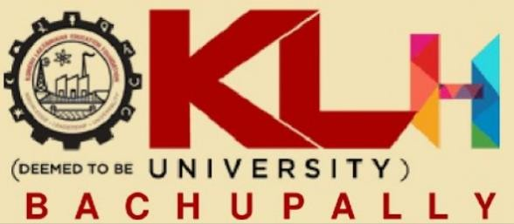

Hyderabad-500090, Telangana, India.

ABSTRACT

Alumni Connect is a console-based Java application developed to strengthen the connection between students and alumni by providing a centralized platform for networking, mentorship, career guidance, and professional interaction. The system allows students to explore alumni profiles using various search criteria such as technical skills, areas of expertise, graduation year, organization, job role, higher education, location, and professional interests. Based on the selected criteria, the application identifies suitable alumni and presents their profile details along with contact information such as email address, phone number, LinkedIn profile, or GitHub account, enabling students to connect with them through external communication platforms.

In addition to profile searching, the application provides features such as advanced filtering, profile comparison, personalized alumni recommendations, bookmarking favourite alumni, recently viewed profiles, and search history management. Administrators can efficiently maintain the alumni directory by adding, updating, or removing records, ensuring that the information remains accurate and up to date. The system also generates useful insights, including alumni distribution across companies, industries, graduation batches, and technical domains, helping students better understand career trends and opportunities.

The application is designed to deliver quick and accurate search results through optimized searching and recommendation techniques while operating entirely in a console environment without the use of a database or graphical user interface. By providing an organized and interactive way to discover experienced professionals, Alumni Connect encourages knowledge sharing, mentorship, and stronger alumni–student relationships. The project demonstrates how an efficient console-based application can solve a real-world networking problem while offering a practical platform for career exploration and professional development.

Signature of the Guide

